Lab Title: Wireshark – HTTP (Hypertext Transfer Protocol)
Submitted By: M. Hasnain Naeem (212728)
Section: BSCS-7B
Objective of this lab:

In this lab, we’ll explore several aspects of the HTTP protocol: the basic GET/response interaction, and HTTP message formats.

Instructions:

- Read carefully before starting the lab.
- These exercises are to be done individually.
- You are supposed to provide the answers to the in-line questions in this document and upload the completed document to your course’s LMS site.
- For all questions, you must not only answer the question, but also supply all necessary information regarding how you arrived at the answer (e.g., use screenshots/ accompanying text, etc.) Use red font color to distinguish your replies from the rest of the text.
- Avoid plagiarism by copying from the Internet or from your peers. You may refer to source/ text but you must paraphrase the original work.
Background:

The world’s web browsers, servers and related web applications all talk to each other through HTTP, the Hypertext Transfer Protocol. Before proceeding to the experiments, it is recommended that you read introductions to some general terms used in this lab, to avoid any confusion.

- What is a web page?
A Web page (also called a document) consists of objects. An object is a simple file -- such as a HTML file, a JPEG image, a GIF image, a Java applet, an audio clip, etc. -- that is addressable by a single URL. Most Web pages consist of a base HTML file and several referenced objects. For example, if a Web page contains HTML text and five JPEG images, then the Web page has six objects: the base HTML file plus the five images. The base HTML file references the other objects in the page with the objects' URLs. Each URL has two components: the host name of the server that houses the object and the object's path name. For example, the URL www.someSchool.edu/someDepartment/picture.gif has www.someSchool.edu for a host name and /someDepartment/picture.gif for a path name.
- What is a web browser?
A browser is a user agent for the Web; it displays to the user the requested Web page and provides numerous navigational and configuration features. Web browsers also implement the client side of HTTP. Thus, in the context of the Web, we will interchangeably use the words "browser" and "client". Popular Web browsers include Google Chrome, Netscape Communicator, Apple Safari and Microsoft Explorer.

- What is a web server?
A Web server hosts Web objects, each addressable by a URL. Web servers also implement the server side of HTTP. Popular Web servers include Apache, Microsoft Internet Information Server, and the Netscape Enterprise Server.
- Introduction to HTTP:
The Hypertext Transfer Protocol (HTTP), the Web's application-layer protocol, is at the heart of the Web. HTTP is implemented in two programs: a client program and server program. The client program and server programs, executing on different end systems, talk to each other by exchanging HTTP messages. HTTP defines the structure of these messages and how the client and server exchange the messages. HTTP defines how Web clients (i.e., browsers) request Web pages from servers (i.e., Web servers) and how servers transfer Web pages to clients. When a user requests a Web page (e.g., clicks on a hyperlink), the browser sends HTTP request messages for the objects in the page to the server. The server receives the requests and responds with HTTP response messages that contain the objects.
Steps for performing this lab:
For all the experiments we will use Wireshark packet analyzer.

Exercise 01: The Basic HTTP GET/response interaction

Aim of this exercise: We will now learn about what packets are exchanged during a HTTP conversation---we will learn about the HTTP GET message that is sent from the HTTP client to the HTTP server and the HTTP message that is sent as response to this message.
Follow the steps below to complete this exercise and to provide answers to the questions below
- Start up your web browser.
- Start up the Wireshark packet sniffer (but don’t yet begin packet capture). Enter “http” (just the letters, not the quotation marks) in the display-filter-specification window, so that only captured HTTP messages will be displayed later in the packet-listing window. (We’re only interested in the HTTP protocol here, and don’t want to see the clutter of all captured packets).
- Begin Wireshark packet capture.
Enter the following to your browser http://gaia.cs.umass.edu/wireshark-labs/HTTP-wireshark-file1.html. Your browser should display the very simple, one-line HTML file.
- Stop Wireshark packet capture.

The example in Figure 1 shows in the packet-listing window that two HTTP messages were captured: the GET message (from your browser to the gaia.cs.umass.edu web server) and the response message from the server to your browser. The packet-contents window shows details of the selected message (in this case the HTTP GET message, which is highlighted in the packet- listing window). Recall that since the HTTP message was carried inside a TCP segment, which was carried inside an IP datagram, which was carried within an Ethernet frame, Wireshark displays the Frame, Ethernet, IP, and TCP packet information as well.

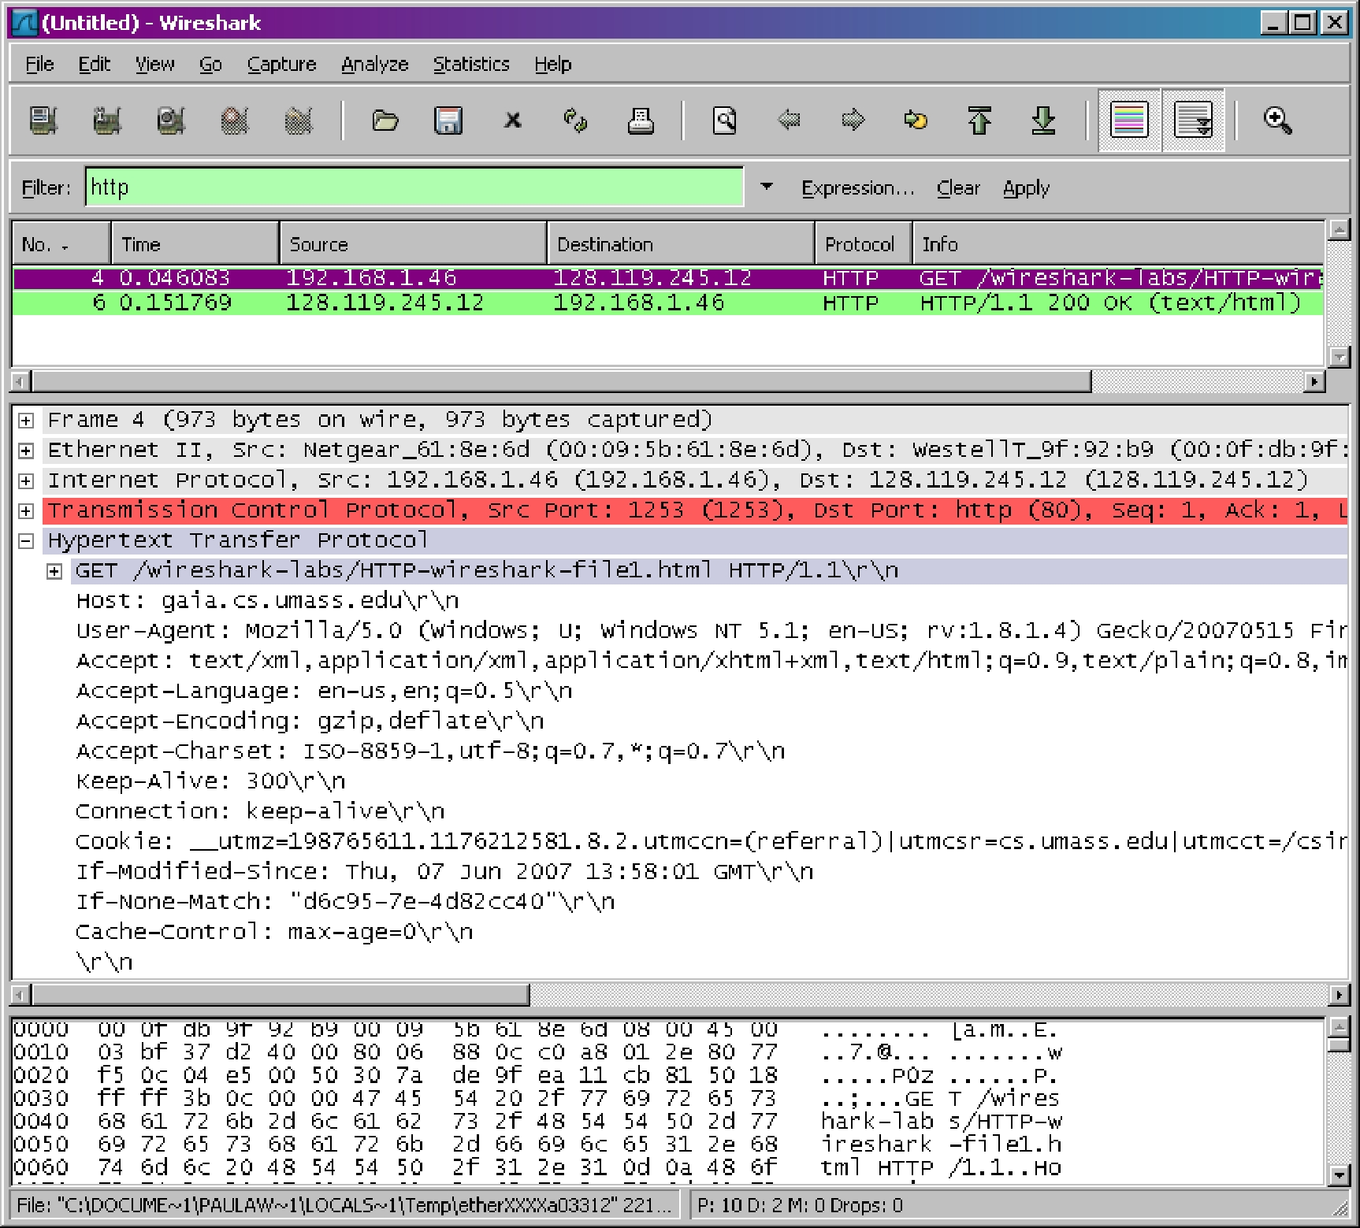

Figure 1: Wireshark display after http://gaia.cs.umass.edu/wireshark-labs/ HTTP-wireshark-file1.html has been retrieved by your browser

By looking at the information in the HTTP GET and response messages that you have captured, answer the following questions:
Objectives:
- Knowledge of protocols used in application layer
- Getting familiar with HTTP GET and response messages
- Inspecting HTTP packets using Wireshark
- Understanding the data/information/flags in HTTP packets
Conclusion:
Browser uses HTTP protocol to send and receive HTTP packets to and from the server. We can inspect those packets using the wireshark software. Header files and objects sent from the server by the client and requests sent by the client to server can be analyzed through inspection of HTTP packets.

IP Address:
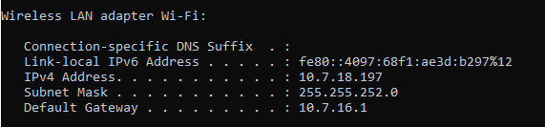

  - Which version of HTTP is the browser running 1.0 or 1.1? Which HTTP version is the server running?
Browser is running HTTP 1.1.

  - What is the status code returned from the server to your browser?
200 is the code returned, which means data was fetched successfully.
  - When was the HTML file that you are retrieving last modified at the server?
Date Returned: Sun, 15 Sep 2019 05:59:01 GMT
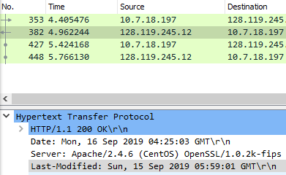
  - How many bytes of content are being returned to your browser?
Bytes Returned: 128
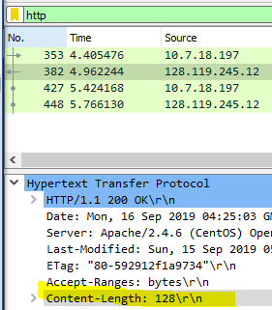
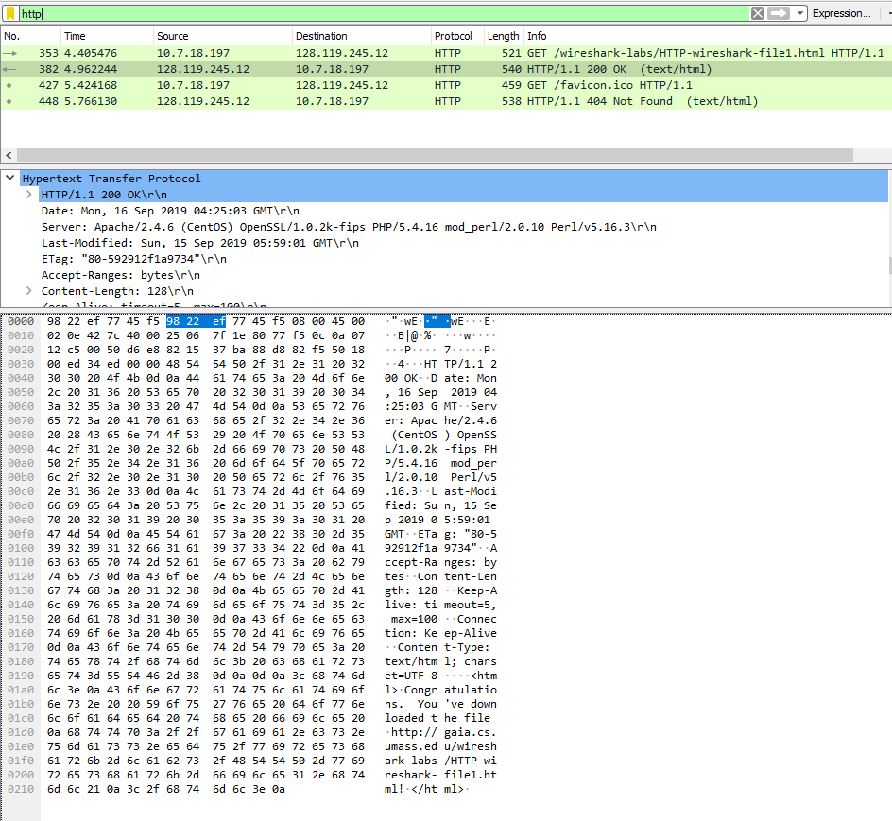
Exercise 02: The HTTP CONDITIONAL GET/response interaction

Aim of this exercise: We will now learn about a variant of the HTTP GET request message that we’ve seen earlier. We will note how the HTTP CONDITIONAL GET request, and the reply to such a request differs from a simple HTTP GET request. Before performing the steps below, make sure your browser’s cache is empty. (To do this under Firefox, select Tools->Clear Recent History and check the Cache box, or for Internet Explorer, select Tools->Internet Options->Delete File; these actions will remove cached files from your browser’s cache.)
The following indicate the steps for this experiment:

- Start up your web browser, and make sure your browser’s cache is cleared, as discussed above.

- Start up the Wireshark packet sniffer

Enter the following URL into your browser http://gaia.cs.umass.edu/wireshark-labs/HTTP-wireshark-file2.html

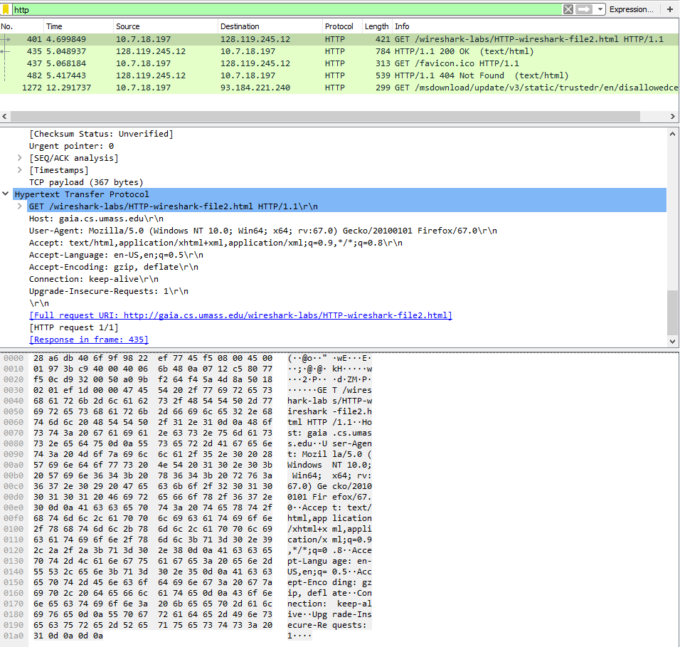
Your browser should display a very simple five-line HTML file.
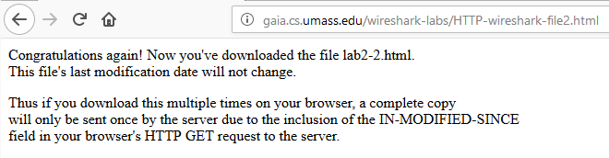

- Quickly enter the same URL into your browser again (or simply select the refresh button on your browser). Stop Wireshark packet capture, and enter “http” in the display-filter-specification window, so that only captured HTTP messages will be displayed later in the packet-listing window.
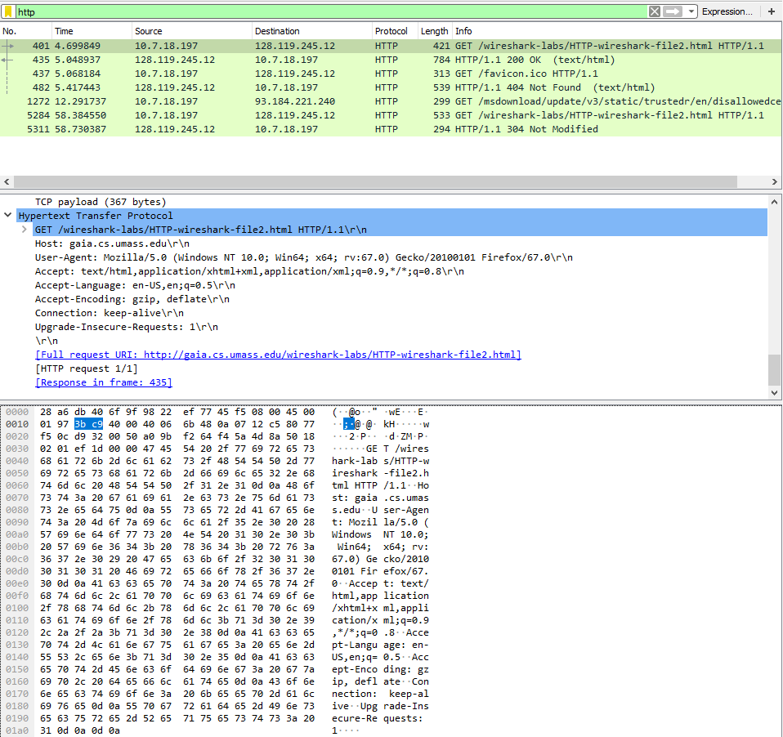

- Filter out all the non-HTTP packets and focus on the HTTP header information in the packet-header detail window.
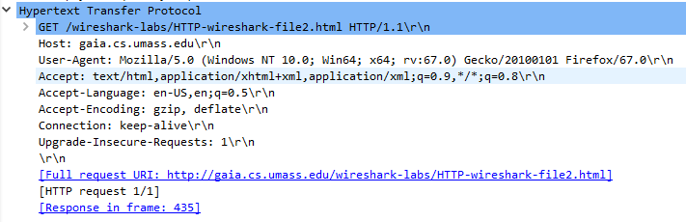

By looking at the information in the HTTP GET and response messages, answer the following questions:

  - Inspect the contents of the first and 2nd HTTP GET requests from the browser to the server. Do you see “IF-MODIFIED-SINCE” and “IF-NONE-MATCH” lines in these HTTP GET message? Why?
- Yes.
- As this page was saved in the cache. Browser asked the server through HTTP Get request, if the page is not modified (through If-Modified-Since flag) since the given date, then do not send all the objects. Intead, send the header bits only and a response of 304.
- If-None-Match checks if the resource is there or not, if it is there then the condition of if-modified-since is checked.
- Value of if-none-match is also known as ETag, which is used to make sure the objects of the requested page are changed or not since the given date.
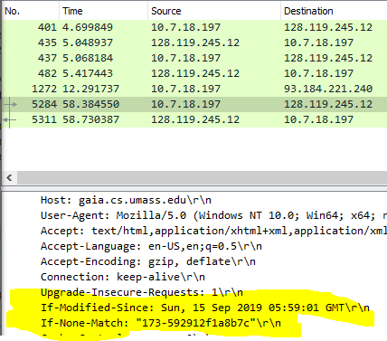

  - What is the difference in first and second response received? What is the last modified time in the first response message?
Last modified date in 1st response: Sun, 15 Sep 2019 05:59:01 GMT
Last modified date in 2nd response: Sun, 15 Sep 2019 05:59:01 GMT

Response of first GET request was 200, which means all the objects were fetched succesfully from the server.
Response of the second GET request was 304, which means only the header bits were sent and object files were fetche from the cache because of the if-modified-since and if-none-match flags.
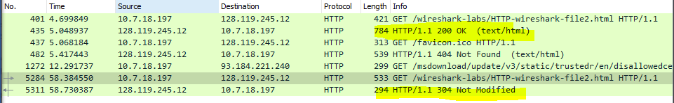

  - What is the HTTP status code and phrase returned from the server in response to the first and second HTTP GET? Did the server explicitly return the contents of the file? Explain.
Status code: 200 – all objects were fetched successfully
Status code description: OK
Yes, the contents of file were explicity returned as indicated by the status code 200 and file content in the sniffed packets.
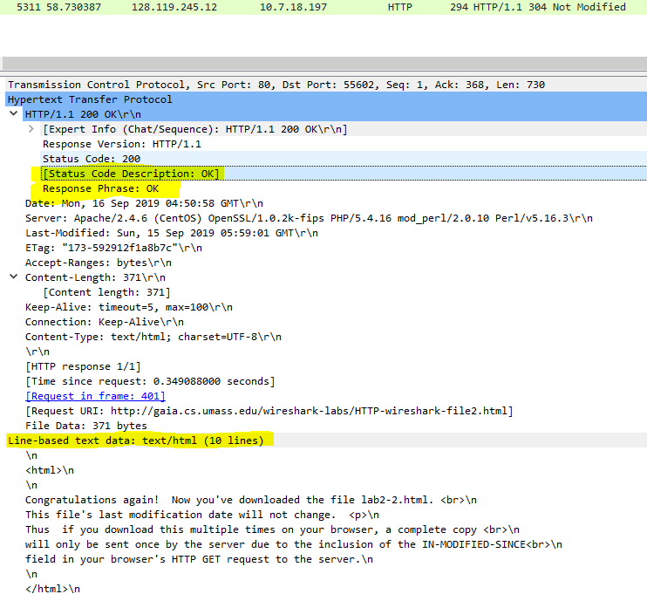
Empty your browser cache again and open the webpage www.seecs.edu.pk and capture the GET and OK response messages. How many total objects does the server return?
254 objects were returned from the host.
839 objects were returned by hot and the sites directed by host.
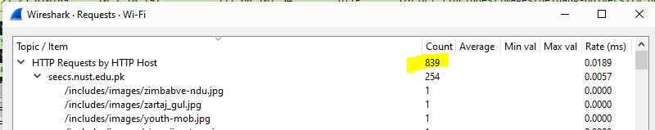

  - What is the page load time (PLT) for the interaction in 2.4?

Time of first GET request: 05:38:10.830370
Time of last response request: 05:38:41.769085
Loading time = 41.77 – 10.83 = 30.94
